Spiritus Annual Discernment 2026
I am interested in further discerning my role as:
Community Volunteer Opportunities  ☐ Planning Spiritus Gatherings  ☐ Helping with Temporalities (setup, last one out, hospitality, etc.)  ☐ Finance Team  ☐ Operating Streaming Equipment  ☐ Community Outreach Ministry  ☐ Social Justice Team  ☐Other________________________ | Leadership team roles  ☐ Community Coordinator  ☐ Formation Coordinator  ☐ Temporalities Coordinator  ☐ Community Rep (3 needed)  ☐ Social Justice Coordinator  ☐ Treasurer  ☐ Spiritual Advisor
Name:____________________________________________________
Email:___________________________________________________
Please return this form to Matt or Maggie or email it to
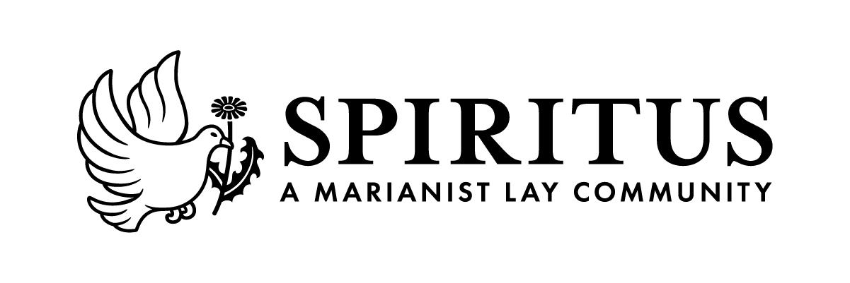
contact@spiritus-mlc.org. Forms due by April 19.

